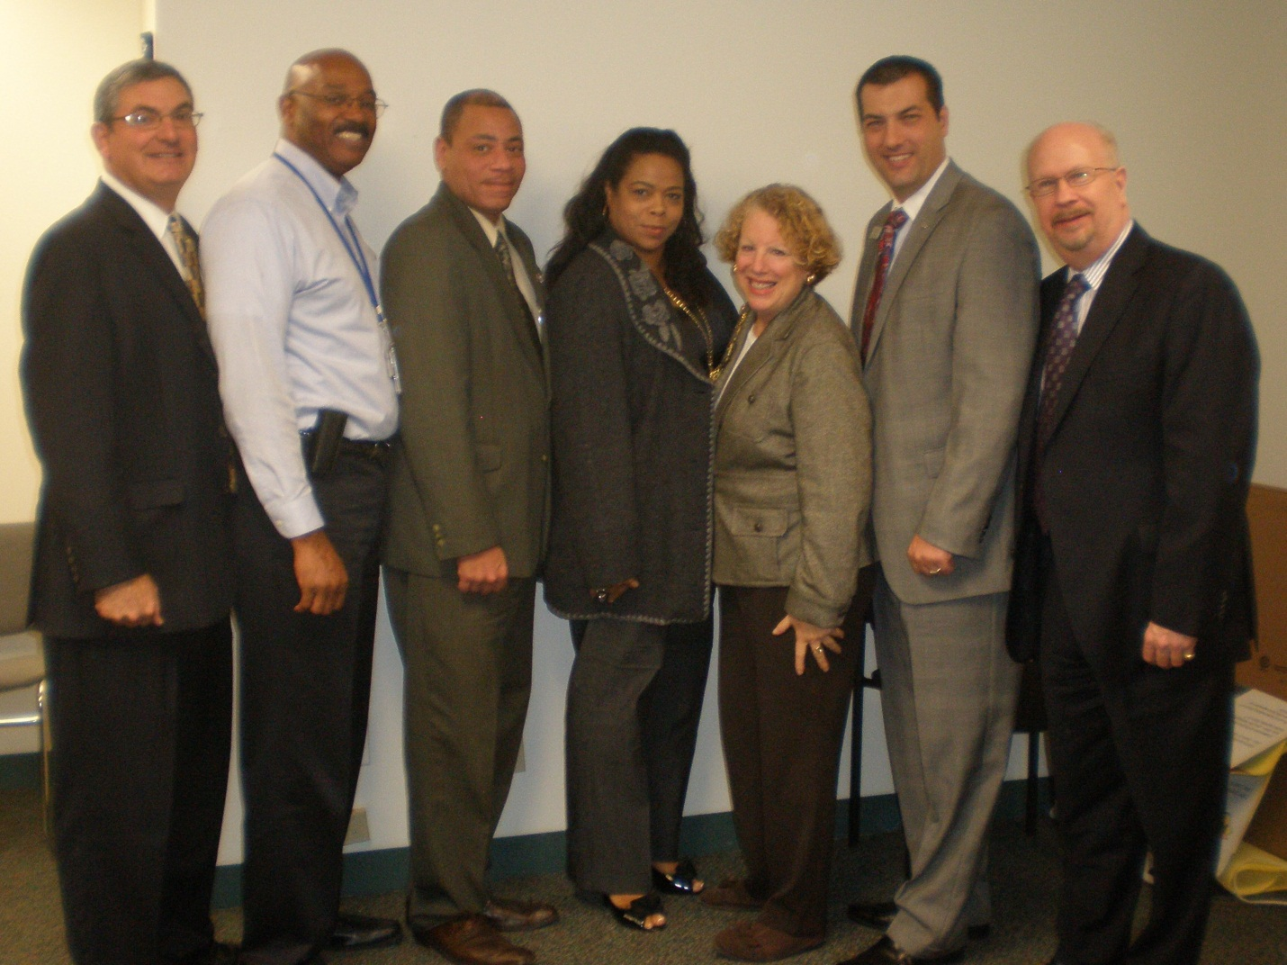

The Hicksville Chamber of Commerce hosted an event to educate small business owners on financing opportunities. (From left) Neil Seiden – Asset Enhancement Solutions, Michael Peacock – SBA, Lionel Chitty – Hicksville Chamber of Commerce, Gina Slater Parker – BWE, Brian Thomas – Capital One, Phil Balin – Capital One.

